- Create a Flask application with an /api route. When this route is accessed, it should return a JSON list. The data should be stored in a backend file, read from it, and sent as a response.
App.py file:
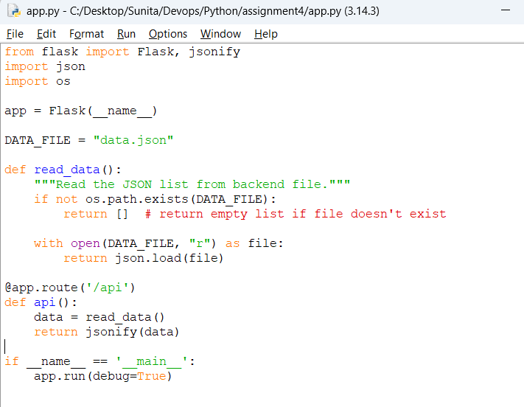
Data.json file
[
{"id": 1, "name": "Apple"},
{"id": 2, "name": "Banana"},
{"id": 3, "name": "Cherry"}
]
Output:
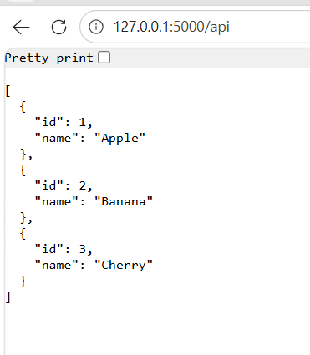

- Create a form on the frontend that, when submitted, inserts data into MongoDB Atlas. Upon successful submission, the user should be redirected to another page displaying the message "Data submitted successfully". If there's an error during submission, display the error on the same page without redirection.
Python Program:
from flask import Flask, render_template, request, redirect
from dotenv import load_dotenv
import pymongo
import os

load_dotenv()

MONGO_URI = os.getenv("MONGO_URI")

client = pymongo.MongoClient(MONGO_URI)
db = client["testdb"]
collection = db["question2"]

app = Flask(__name__)
# ---------------------------
# Show the form + handle submit
# ---------------------------
@app.route("/", methods=["GET", "POST"])
def form_page():
error = None

if request.method == "POST":
name = request.form.get("name")
email = request.form.get("email")

# Simple validation
if not name or not email:
error = "Please enter both name and email."
return render_template("index.html", error=error)

try:
# Insert into MongoDB
collection.insert_one({"name": name, "email": email})
return redirect("/success") # Success redirect
except Exception as e:
error = "Error: " + str(e)
return render_template("index.html", error=error)

return render_template("index.html", error=error)

# ---------------------------
# Success page
# ---------------------------
@app.route("/success")
def success():
return "Data submitted successfully!"

if __name__ == "__main__":
app.run(debug=True)

form data accepted from Html file.

Index.html stored in templates

<html>
<body>
<h2>Submit Your Info</h2>
<!-- Show error if exists -->
{% if error %}
<p style="color:red;">{{ error }}</p>
{% endif %}
<form method="POST">
<label>Name:</label><br>
<input type="text" name="name"><br><br>
<label>Email:</label><br>
<input type="email" name="email"><br><br>
<button type="submit">Submit</button>
</form>
</body>
</html>

Directory structure:

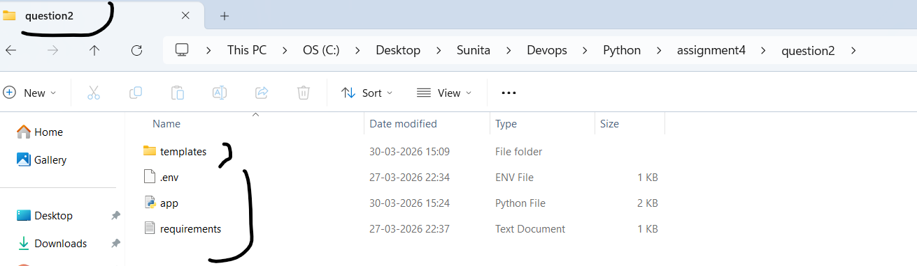

Output:

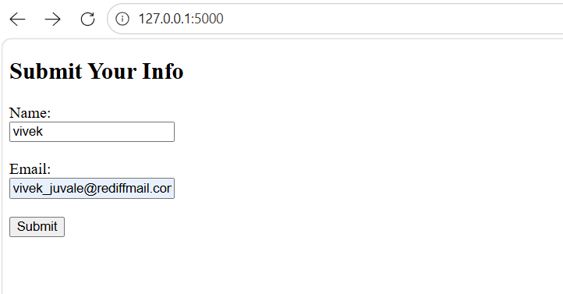

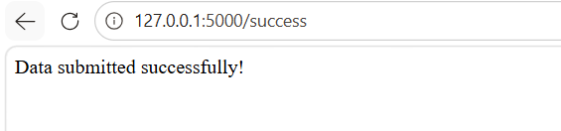

Data stored in mongo dbside:

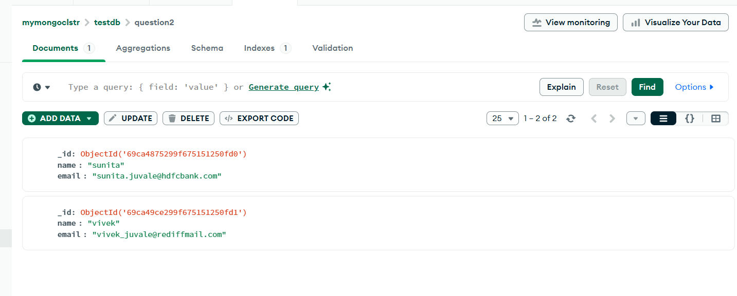

Front end Validation on incorrect Name or EmailId

When blank data submitted.

